Class Diagram:

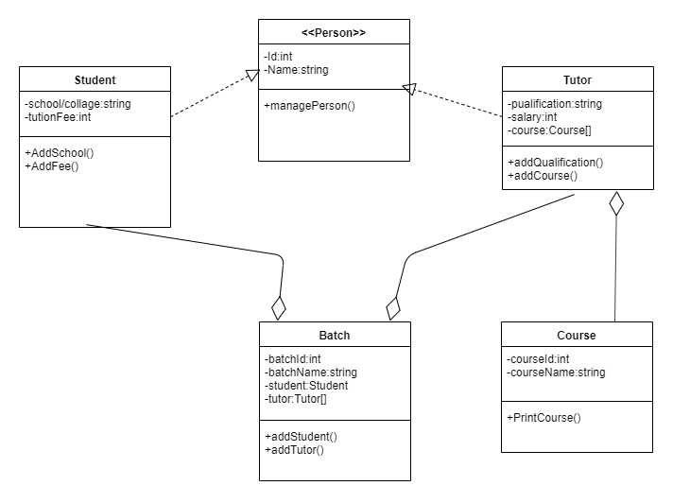

GitHub Profile:

Assignment path:

|  |  |
| --- | --- |
| using System;  namespace StudentManagement  {  class Program  {  static void Main(string[] args)  {  Course c1 = new Course("HSC 1ST", 5000);  Person t1 = new Tutor(10, "Eraj", "Honors");  Person t2 = new Tutor(11, "Muntasir", "Honors");  Person s1 = new Student(3, "Rahim", "Model Collage");  Person s2 = new Student(5, "Kahim", "Kamarujjaman Collage");  Person s3 = new Student(4, "Lahim", "City Collage");  Person s4 = new Student(6, "Fahim", "Model Collage");  Batch b1 = new Batch(101, "ABC");  b1.AddStudent(s1,s2);  b1.AddTutor(t1);  b1.ShowBatch();  Console.WriteLine();  Console.WriteLine();  Batch b2 = new Batch(102, "DEF");  b2.AddStudent(s3, s4);  b2.AddTutor(t2);  b2.ShowBatch();  }  }  } | using System;  namespace StudentManagement  {  public class Course  {  static int id=0;  int courseId;  string courseName;  public Course(string courseName,int courseFee)  {  id++;  this.CourseId = id;  this.CourseName = courseName;  }  public int CourseId { get => courseId; set => courseId = value; }  public string CourseName { get => courseName; set => courseName = value; }  public void PrintCourse()  {  Console.WriteLine("Course Id :{0}\nCourse Name :{1}\nCourse Fee :{2}",this.CourseId,this.courseName);  }  }  } |

|  |  |
| --- | --- |
| using System;  namespace StudentManagement  {  public class Tutor : Person  {  string qualification;  int salary;  public Tutor(int id,string Tutorname,string qualification)  {  this.Id = id;  this.Name = Tutorname;  this.qualification = qualification;  }  public override void AddPayment(int amount)  {  salary = amount;  }  }  } | using System;  namespace StudentManagement  {  public class Student : Person  {  string schoolcollage;  int tutionFee;  public Student(int sId,string studentName,string schoolcollage)  {  this.Id = sId;  this.Name = studentName;  this.schoolcollage = schoolcollage;  }  public override void AddPayment(int amount)  {  this.tutionFee = amount;  }  public string School_collage { get => schoolcollage; set => schoolcollage = value; }  public int TutionFee { get => tutionFee; set => tutionFee = value; }  }  } |

|  |  |
| --- | --- |
| using System;  namespace StudentManagement  {  public class Batch  {  static int count = 0;  int batchId;  string batchName;  Person[] student = new Student[6];  Person[] tutor = new Tutor[2];  public Batch(int batchId,string batchName)  {  this.BatchId = batchId;  this.BatchName = batchName;  count++;  }  public int BatchId { get => batchId; set => batchId = value; }  public string BatchName { get => batchName; set => batchName = value; }  public Person[] Student { get => student; set => student = value; }  public Person[] Tutor { get => tutor; set => tutor = value; }  public void AddStudent(params Person[] student)  {  for (int i = 0; i < student.Length; i++)  {  if (this.student[i] == null)  {  this.student[i] = student[i];  }  }  } | public void AddTutor(params Person[] tutor)  {  for (int i = 0; i < tutor.Length; i++)  {  if (this.tutor[i] == null)  {  this.tutor[i] = tutor[i];  }  }  }  public void ShowBatch()  {  Console.WriteLine("Batch---------------------");  Console.WriteLine();  Console.WriteLine("Batch Id :"+this.batchId+"\n"+"Batch Name :"+this.batchName);  Console.WriteLine();  Console.WriteLine("Teacher-------------------");  Console.WriteLine();  tutor[0].Show();  Console.WriteLine();  Console.WriteLine("Student-------------------");  Console.WriteLine();  for (int i = 0; i < this.student.Length; i++)  {  if(this.student[i]!=null)  student[i].Show();  }  }  }  } |